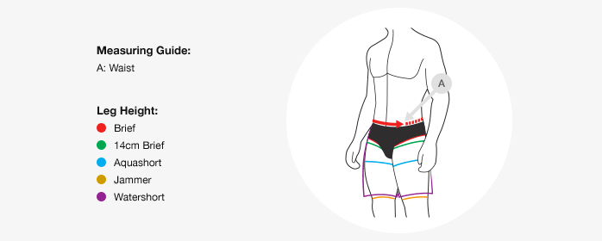

Speedo Men
Our men's swimwear sizing is based on your waist measurement in inches.
Speedo Size | Waist  (inches / cm) | Germany | France  (cm) | Italy | Australia
26 | 26" / 65cm | 1 | 65 | 40 | -
28 | 28" / 70cm | 2 | 70 | 42 | -
30 | 30" / 75cm | 3 | 75 | 44 | -
32 | 32" / 80cm | 4 | 80 | 46 | 12
34 | 34" / 85cm | 5 | 85 | 48 | 14
36 | 36" / 90cm | 6 | 90 | 50 | 16
38 | 38" / 95cm | 7 | 95 | 52 | 18
40 | 40" / 100cm | 8 | 100 | 54 | 20
42 | 42" / 105cm | 9 | 105 | 56 | 22
44 | 44" / 110cm | 10 | 110 | 58 | 24

